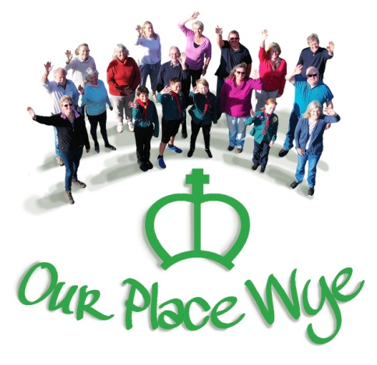

OUR PLACE WYE COMMUNITY COMPANIONS

During the coming weeks you may become bored with being stuck inside your home for long periods of time and crave a good old chat with someone. Maybe you would benefit from our free befriending service. Our volunteers provide a regular friendly phone call to help reduce the feelings of isolation.

For more information about the befriending service, in the first instance please call your Our Place Wye local coordinators:

Local contact 1: xxxx
Local contact 2: xxxx
Local contact 3: xxxx

If you don’t get through, then please call the scheme coordinators: Mary on 01233 813762 or Richard on 07969583920.

This card was produced and delivered using the strictest and most up-to-date hygiene and safety guidance. Up-to-date hygiene and safety guidance will be provided to anyone volunteering to help.

